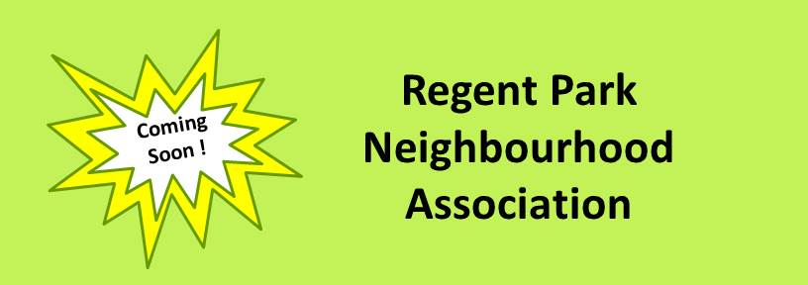
To All Residents…

Get involved in the new Regent Park Neighbourhood Association (RPNA) and help build our vibrant community!

We need you. And Regent Park needs you.

With a strong neighbourhood association, residents will have a powerful voice – and no one has a greater stake in the future of our neighbourhood than we do, the people who live here.

Joining RPNA is an easy way to make a big difference while getting to know amazing neighbours who share your passion for Regent Park, one of the most dynamic and diverse communities in Canada.

Get involved! Help spread the word about the RPNA in your building and at community events, and run for the RPNA Rep Election in your building!
For more information, email: rpna.info@gmail.com

FAQs
Q: What does RPNA do and what are its goals?
A: The purpose of RPNA is to build an inclusive and thriving community through…

- Advocacy – providing a strong voice for residents on issues that will benefit the entire community such as improving safety and building more opportunities for our youth.

- Community-Building – bringing our culturally diverse and mixed-income neighbourhood together through events such as Spring Cleanup, or the CSI Potluck that we are co-hosting on April 12.

- Communication – developing an information hub for this busy community through a new website, and an e-newsletter in partnership with other Regent Park organizations.

Q: How will RPNA be structured?
A: RPNA will be representative of every building in Regent Park, and the RPNA Board will be made up 50% of TCH reps and 50% condo reps. This structure will ensure broad representation, so that RPNA will be able to play a powerful advocacy role on behalf of the entire community. Also, with a Board made up 50% of TCH reps, RPNA can benefit from Regent Park’s past experiences of grassroots initiatives, self-help ventures, and networks of friendship.

During 2016, each residential building or townhouse group will elect 1-3 RPNA Reps, depending on the number of units in the building or group. RPNA Rep elections are expected to take place at the same time as Building Council Elections for TCH buildings or Annual General Meetings for condo buildings. Once all buildings hold RPNA Rep elections, probably by late 2016, elected Reps will meet to elect a Board of Directors, whose 8-10 members will be 50% TCH Reps and 50% condo Reps.

Q: What buildings will be considered to be within the boundaries of Regent Park?
A: RPNA will include all residential buildings within the following proposed boundaries:

Q: What are the responsibilities of an RPNA Rep?
A: RPNA Reps will attend RPNA Assembly meetings four times a year to vote on key issues, to provide input into current concerns, and to stay informed about the work of RPNA. Reps will also provide a two-way information channel between the association and the residents in their building or townhouses.

Q: How much work is involved?
A: In addition to attending four 2-hour meetings each year, members will be asked to contribute to email discussions so can expect to spend an additional 2-3 hours per month.

Reps may also get involved in one of RPNA’s committees – or run to be a member of the Board of Directors, which will probably meet monthly.

Q: If I’m not an elected RPNA Rep, can I still participate in the RPNA?
A: Yes, RPNA’s three committees – Advocacy, Community-Building, and Communication – will always be looking for volunteers who can bring creative ideas and a willingness to help. And right now we need lots of help running elections and making our neighbourhood aware of the new RPNA.

Q: How do I sign up to run for the RPNA election in my building or to volunteer? Where can I ask further questions?
A: Please contact us at: rpna.info@gmail.com

Apr. 5/16

